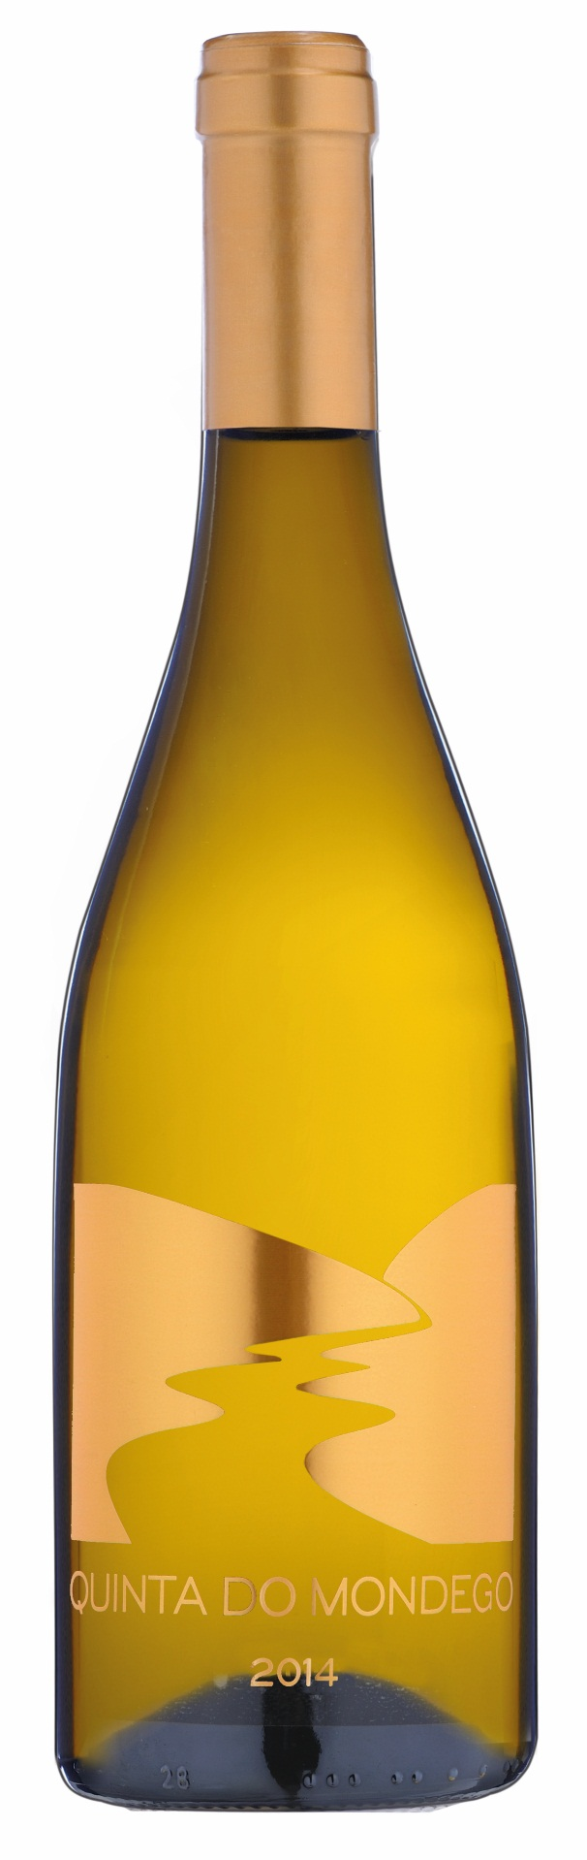

**Tasting notes:**

Beautiful and attractive yellow citrus color. Attractive and fresh. Aromatic intense: lemon, mint, bread crumbs and mineral.

Well balanced, fresh and dry. The intensity of flavor dominated by lemon fruit, mint and minerals

Persistent finish

**Winemaking**:

Soft stalk-removal and crushing. Gentle press and natural decantation at low temperatures for 24h. Fermentation of the Gouveio in stainless steel tanks at a controlled temperature and aging in the tank with lees stirring. Fermentation of the Encruzado in 500L french barrels (2nd year) and aging for 6 months with frequently battonage

**UPC**

**CASE CONTENT: 12x750ML**

**CASE WEIGHT: 35 Lb.**

**CASE QTY per pallet LAYER: 15 (75 total)**

***Appellation****: Nelas - Portugal*

***Vintage:*** *2015*

***Alcohol:*** *13,2% by Vol.*

***Winery:*** *Quinta Fontes da Cunha*

***Winemaker:*** *Joana Cunha*

Quinda do Mondego white

Encruzado, Gouveio or Verdelho

T. 704 638-0004 | email: sales@ecovalleyimports.com | www.ecovalleyimports.com

