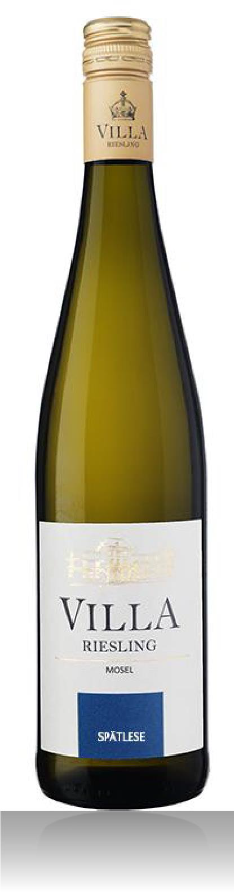Villa Riesling
Spatlese

Appellation: Mosel Valley - Germany
Alcohol: 7,5% by Vol. Winery: Römerhof

A breath taking vineyard location on steep slate slopes facing south along side the Mosel river.
The stones on the ground radiate heat and the water reflects light back up to the vineyard creating great ripening conditions for the grapes.

Winemaking:

Literally means late harvest; made from riper grapes that usually have been picked a later stage in the harvest. These wines are more intense in flavor and concentration. Good with richer, more flavorful foods or by themselves.

Spatlese is a riper category than Kabinett in the category of the German wine classification; it is one of the best.

Tasting notes:

Expressive open nose leads to a powerful palate with lovely mineral presence, enhancing the fresh lemon, melon and honey flavors.

UPC 827599900920
CASE CONTENT: 12x750ML CASE WEIGHT: 37 Lb.
CASE QTY per pallet LAYER: 14 (70 total)

T. 704 638-0004 | email: sales@ecovalleyimports.com | www.ecovalleyimports.com

