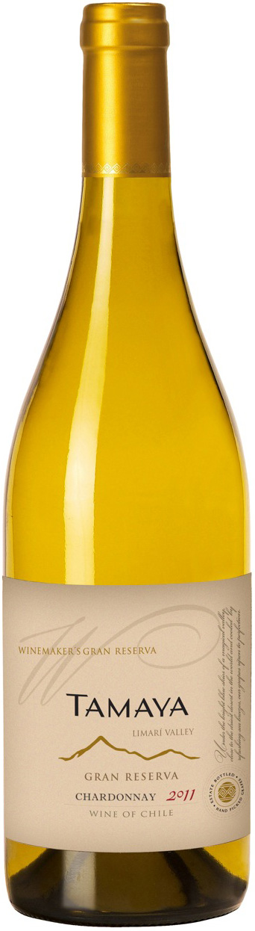

**Tasting notes:** Dressed with a pale gold yellow, dense and brilliant. Great chardonnay identity, made of ripe apples, white peaches and pears, soft lemon and tangerines. Subtle honey hints wrapped in white flowers such as acacia with noble touches of fine spices, bread crust, cream and smoke. The palate is dazzling all the way thanks to minerality and crucial soft acidity. Well structured, the texture expresses a great balance. The aromatic complexity and the bright and long finish offers its young fruit with hazelnut and honey, with floral hints.

**Winemaking**: Harvested by hand. A second selection is made just before entering the press, without destemming, under gas protection. Low pressing pressure and few rotations obtain the cleanest and clearer juice. The rape is decanted and fermented with selected yeasts. Temperatures are kept between 14 and 16°C. When fermentation is well advanced, half of the juice goes to 400L French oak barrels to keep on fermenting, while the rest is fermented in steel tanks. From fermentation until the end of the process, wine is in contact with its fine lees, removing them (batonnages) twice a week to get better volume and character. The barrels are checked every week, until finding the perfect balance between fruit and wood. When we reach the expected balance, around 8 months after, we take out the wine from the barrels and keep it during two months in tank, checking its evolution before programming its bottling. The final blend resulted being 90% barrels, 10% tank

**UPC 8-54450-00041--3**

**CASE CONTENT: 12x750ML**

**CASE WEIGHT: 40 Lb.**

**CASE QTY per pallet LAYER: 11 (55 total)**

***Appellation****: Limarí Valley - Chile*

***Vintage:*** *2011*

***Alcohol:*** *14,0% by Vol.*

***Winery:*** *Viña Tamaya*

***Winemaker:*** *José Pablo Martin*

Tamaya Winemakers Gran Reserva

Carmenere

T. 704 638-0004 | email: sales@ecovalleyimports.com | www.ecovalleyimports.com

