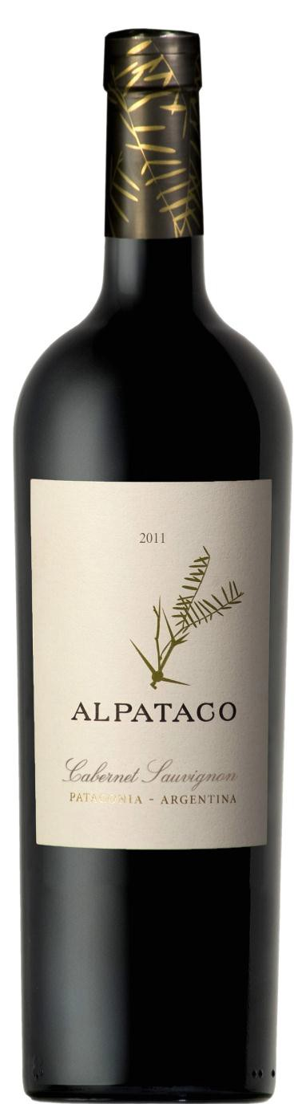Alpataco
Cabernet Sauvignon

Appellation: Patagonia - Argentina Vintage: Current
Alcohol: 14% by Vol. Winery: Familia Schroeder

Alpataco is an indigenous bush which symbolizes the tenacity of life in the Patagonian steppe.
The low yields of the vineyard combined with the expert touch of the winemaker result in wines of great structure and balance.

Winemaking:

Harvested by hand, then manually selected on vibratory table
Alcoholic fermentation in stainless steel tanks with selected enzymes and yeasts for 10 days at 27ºC. Three days’ maceration time at low temperatures with carbonic gas and dry ice. After fermentation, a seven- day maceration at low temperature. 100% malolactic fermentation with lactic bacteria cultures in stainless steel tanks. 40% aged for six months in French and American oak barrels. 60% stored in stainless steel tanks until blending.

Tasting notes:

Deep bright red color. Compelling mix of different aromas like red fruits, black pepper and spices.
The oak brings some vanilla and coffee notes. This Cabernet is well structured, fresh and fruity. A young wine with very well defined characteristics.

UPC 827599900920
CASE CONTENT: 12x750ML CASE WEIGHT: 37 Lb.
CASE QTY per pallet LAYER: 14 (70 total)

T. 704 638-0004 | email: sales@ecovalleyimports.com | www.ecovalleyimports.com

