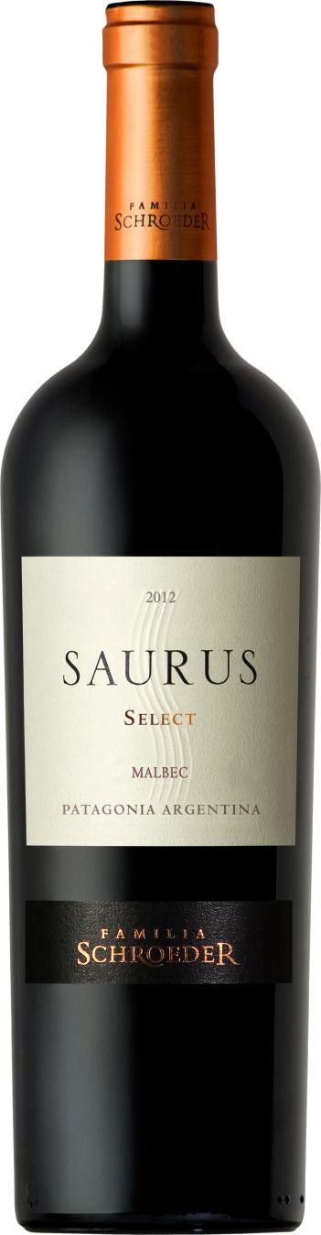Saurus Select
Malbec

Appellation: Patagonia - Argentina Vintage: Current
Alcohol: 14,0% by Vol.
Winery: Familia Schroeder Winery

“In 1999, during the construction of our winery, fossils of an Aeolosaurus were found at the site. The name comes from the Greek “Aeolo”, which means wind and “Saurus”, which means lizard.
Such an important discovery inspired us to name our first line of wines Saurus!” – Familia Schroeder

Winemaking:

Picked by hand. Hand selection of bunches in vibratory table. Alcoholic fermentation in stainless steel tanks with selected enzymes and yeasts. Three days’ maceration time in cold with carbonic gas; ten- day fermentation and finally five-day maceration. Malolactic fermentation, 60% in stainless steel tanks and 40% in oak barrels. 40% aged for 12 months in new French and American oak barrels (medium and medium plus toasted) and 60% stored in stainless steel tanks to keep the fruit.

Tasting notes:

This Malbec features an intense dark purplish red color with ruby highlights. Ripe red fruit aromas such as currants, plums and sour berries melt along with some spicy hints. The barrel aging brings some vanilla and coffee notes. The mouth-feel is pleasant and well balanced and the long, lingering finish is dominated by sweet, velvety tannins.

UPC 827599900920
CASE CONTENT: 12x750ML CASE WEIGHT: 37 Lb.
CASE QTY per pallet LAYER: 14 (70 total)

T. 704 638-0004 | email: sales@ecovalleyimports.com | www.ecovalleyimports.com

