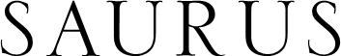

PINOT NOIR
Limited Edition

VARIETAL COMPOSITION
100% Pinot Noir

YIELD
3.6 tons / acre
8.9 tons / hectare

HARVEST METHOD
Hand-picked bunches. Hand-sorting of grapes in table.

MACERATION TIME
Four hours at low temperatures inside the pneumatic press (protected with dry ice – CO2). Gently crushing of the grapes with low pressure (less than 1.2 Bar)

ALCOHOLIC FERMENTATION
Fourteen days at 15ºC in stainless steel tanks with selected enzymes and yeasts.

MALOLACTIC FERMENTATION
No malolactic fermentation was done, in order to keep the natural malic acidity.

AGEING
Five and a half months at low temperatures in stainless steel tanks with its fine lees to obtain a creamy mouth-feel and to keep fresh fruit flavors.

CLARIFICATION
With bentonite and low temperatures.

TECHNICAL INFORMATION
Alcohol: 12.5% VOL Total acidity: 6.1 G/L PH: 3.30
Residual sugar: 2.0 G/L
PRODUCTION
8000 bottles

TASTING NOTES
The sight offers a pale rose color with delicate salmon-pink hints.
Complex nose with floral aromas, orange blossom and rose petals.
Fresh, fruity and balanced with mouthwatering acidity

WINEMAKER
Lic. Leonardo Puppato

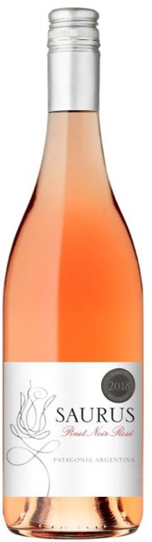

FAMILIA SCHROEDER – PATAGONIA - ARGENTINA
info@familiaschroeder.com / www.familiaschroeder.com

