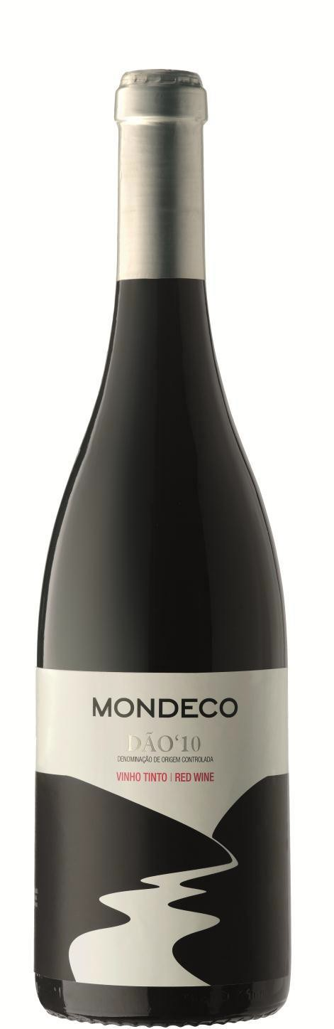Mondeco Red Dao
Tinta Roriz, Touriga Nacional, Alfrocheiro, Jaen, Baga

Appellation: Nelas - Portugal
Alcohol: 13,0% by Vol.
Winery: Quinta Fontes da Cunha

Mondeco is the river that runs with pure crystalline water across Quinta Fontes da Cunha vineyards and meets the ocean not far away from their small boutique family winery.
Jonana Cunha, the winemaker, creates international style wines using indigenous grape varieties.

Winemaking:

The four grape varieties are hand harvested and softly crushed together after de-stemming.
Fermentation in small stainless steel vats at a controlled temperature of under 25ºC
Malolactic fermentation is allowed to occur naturally in the vats.
Aging in French oak casks for 12 months. Light filtration before bottling.

Tasting notes:

Beautiful red ruby color, Very elegant aroma, attractive with fresh mint and fresh fruit – strawberries and raspberries. Good acidity, crispy flavors of fresh fruit, mint and cedar. Fine quality tannins. Balanced and persistent.
Pairs well with a wide selection of meats , game and soft cheeses.

UPC 827599900920
CASE CONTENT: 12x750ML CASE WEIGHT: 37 Lb.
CASE QTY per pallet LAYER: 14 (70 total)

T. 704 638-0004 | email: sales@ecovalleyimports.com | www.ecovalleyimports.com

